**AMERICAN INTERNATIONAL UNIVERSITY-BANGLADESH**

**Faculty of Science and Technology**



**Course Title: Data Communication[G]**

**Final Term Lab Assignment**

|  |  |
| --- | --- |
| ***Submitted by:***  **Name: Shifat, Shadril Hassan**  **ID: 20-42451-1**  **Section: G**  **Program: BSc CSE**  **Semester: Spring 2021-2022**  **Date: 21 February, 2022** | ***Submitted to:***  **Course Teacher: Tanjil Amin** |

**MATLAB Code:**

%ID = AB-CDEFG-H

clc;

clear all;

close all;

A=2;

B=0;

C=4;

D=2;

E=4;

F=5;

G=1;

H=1;

amp_00=0;

amp_01=(G+5);

amp_10= 2*(G+5);

amp_11= 3*(G+5);

%(a)Convert your text message into binary bit sequence.

transmitted_msg='1rS7';

disp('Text message at sender :');

disp(transmitted_msg);

dec=double(transmitted_msg); %Text to ASCII (decimal)

p2=2.^(0:-1:-7); % 2^0,2^-1,.......,2^-7

B=mod(floor(p2'*dec),2); %Decimal to binary conversion

%Columns of B are bits of chars

x=reshape(B,1,numel(B));%Bytes to serial conversion

disp('Binary information at Transmitter :');

disp(x);

%(b)Display the bit sequence from (a) as four level unipolar digital signal. Use 0 volt for binary ‘0 0’, use (G+5) volt for binary ‘0 1’, use 2*(G+5) volt for binary ‘1 0’, use 3*(G+5) volt for binary ‘1 1’. Bit rate of your digital signal must be (G+1)*10 bps.

br=(G+1)*10; %Bit rate

bp=1/br; %Bit period

bit=[];

for n=1:2:length(x)

if x(n)==0 && x(n+1)==0

se=zeros(1,100);

elseif x(n)==0 && x(n+1)==1

se=(G+5)*ones(1,100);

elseif x(n)==1 && x(n+1)==0

se=2*(G+5)*ones(1,100);

else

se=3*(G+5)*ones(1,100);

end

bit=[bit se];

end

t1=bp/50:bp/50:50*length(x)*(bp/50);

figure;

plot(t1,bit,'lineWidth',2.5);

grid on;

%axis([0 bp*length(x) -.5 15]);

xlabel('time(sec)');

ylabel('amplitude(volt)');

title('Transmitting information as digital signal');

%(c)Apply QASK on digital signal from (b). Use a carrier frequency of (G+1)*40 Hz. Assume we are transmitting this analog signal.

cf=br*(G+1)*40; %carieer freq.

t2=bp/100:bp/100:bp;

ss=length(t2);

m=[];

for i=1:2:length(x)

if x(i)==0 && x(i+1)==0

y=0*cos(2*pi*cf*t2);

elseif x(i)==0 && x(i+1)==1

y=(G+5)*cos(2*pi*cf*t2);

elseif x(i)==1 && x(i+1)==0

y=2*(G+5)*cos(2*pi*cf*t2);

else

y=3*(G+5)*cos(2*pi*cf*t2);

end

m=[m y];

end

t3= bp/50:bp/50:bp*length(x);

figure;

plot(t3,m);

grid on;

xlabel('time(sec)');

ylabel('amplitude(volt)');

title('Modulated Signal at Transmitter');

%(d)Add noise to your modulated signal and assume that the noisy signal is your received signal.

t4=bp/50:bp/50:bp*length(x);

Rec=awgn(m,10); %noise added to the signal

%subplot(4,1,3);

figure;

plot(t4,Rec);

xlabel('time(sec)');

ylabel('amplitude(volt)');

title('Received signal at Receiver');

%(e)Recover the bit sequence from the received noisy signal.

mn=[];

for n=ss:ss:length(Rec)

y=cos(2*pi*cf*t2); %carrier signal

mm=y.*Rec((n-(ss-1)):n);

t5=bp/100:bp/100:bp;

z=trapz(t5,mm);% intregation

zz=round((2*z/bp));

if(zz<=(amp_00+amp_01)/2)

a1=0;

a2=0;

elseif(zz>(amp_00+amp_01)/2 && zz<=(amp_01+amp_10)/2)

a1=0;

a2=1;

elseif(zz>(amp_01+amp_10)/2 && zz<=(amp_10+amp_11)/2)

a1=1;

a2=0;

else

a1=1;

a2=1;

end

mn=[mn a1 a2];

end

disp('Binary information at Reciver :');

disp(mn);

%(f)Display the recovered bit sequence from (e) as four level unipolar digital signal. Use 0 volt for binary ‘0 0’, use (G+5) volt for binary ‘0 1’, use 2*(G+5) volt for binary ‘1 0’, use 3*(G+5) volt for binary ‘1 1’. Bit rate of your digital signal must be (G+1)*10 bps.

bit=[];

for n=1:2:length(mn)

if mn(n)==0 && mn(n+1)==0

se=zeros(1,100);

elseif mn(n)==0 && mn(n+1)==1

se=(G+5)*ones(1,100);

elseif mn(n)==1 && mn(n+1)==0

se=2*(G+5)*ones(1,100);

else

se=3*(G+5)*ones(1,100);

end

bit=[bit se];

end

t5=bp/50:bp/50:50*length(mn)*(bp/50);

figure;

plot(t5,bit,'lineWidth',2.5);

grid on;

%axis([0 bp*length(x) -.5 15]);

ylabel('amplitude(volt)');

xlabel('time(sec)');

title('Demodulated signal at receiver');

%(g)Regenerate your text message from recovered bit sequence of (e).

L=length(mn); %Length of input string

L8=8*floor(L/8); %Multiple of 8 Length

B=reshape(mn(1:L8),8,L8/8); %Cols of B are bits of chars

p2=2.^(0:7); %power of 2

dec=p2*B; %Binary to decimal conversion

txt=char(dec); %ASCII (decimal) to txt

disp('Text message at receiver :');

disp(txt);

**Code Output:**

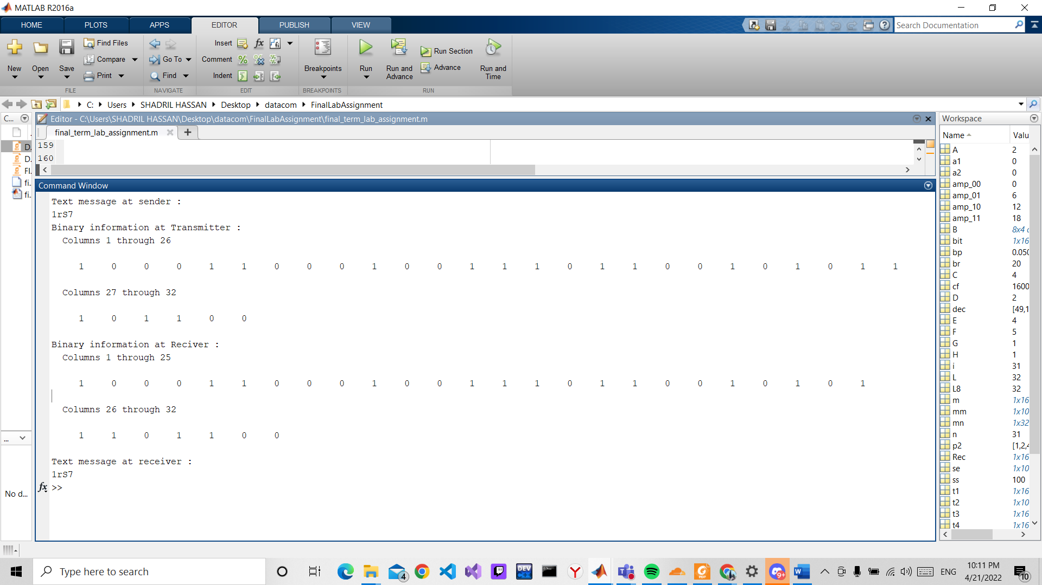

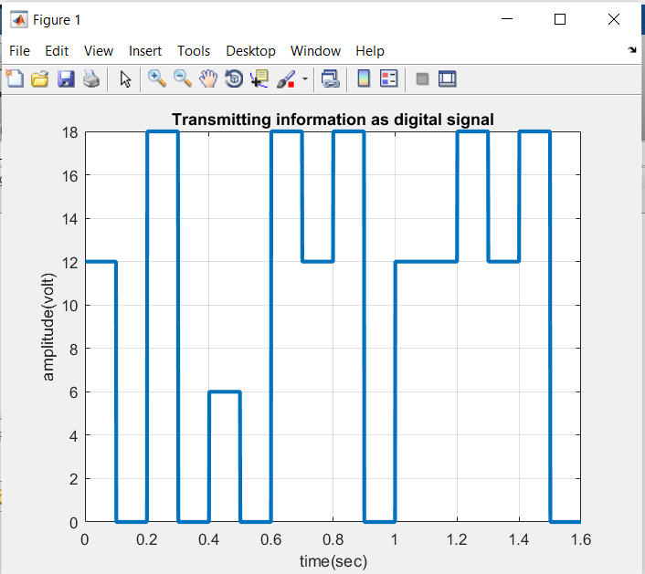

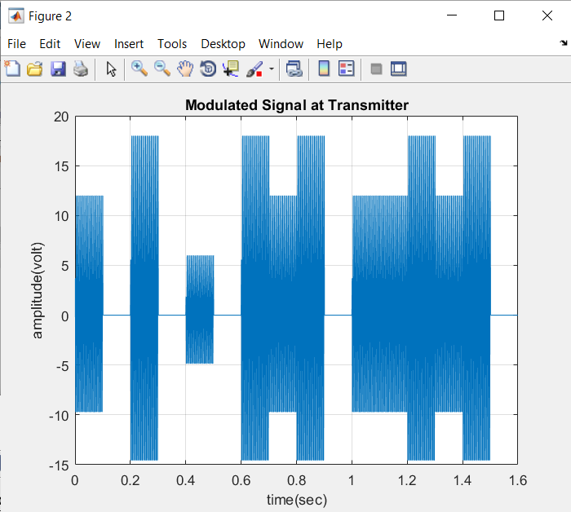

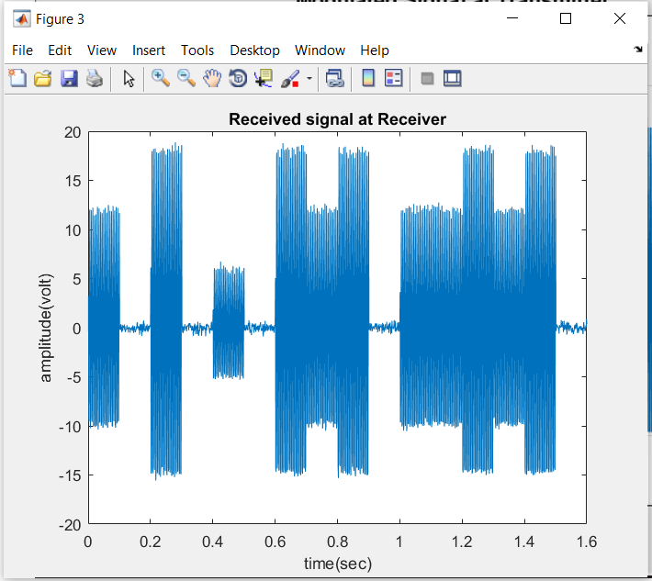

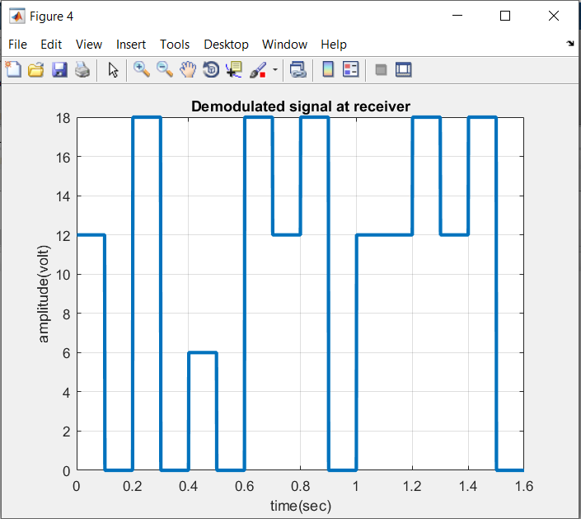

**h)** Increase and decrease noise power at step **(d)** to analyze its impact on communication quality. What is your observation about impact of noise?

**Answer:** In MATLAB built-in function **awgn(sig,snrdb)**, I increased the SNR dB to 100 and also I decreased the SNR dB but it did not affect in accuracy. The whole data was received accurately.